6th Annual Rutgers Critical Care Virtual Symposium

2023

Direct Link for Registration:
https://rutgers.cloud-cme.com/course/courseoverview?P=5&EID=17157

Registration Fee: $75.00
Residents and Fellows Fee: $37.50 `
Ernest Mario School of Pharmacy Students and Faculty: No Charge
[QR Code]

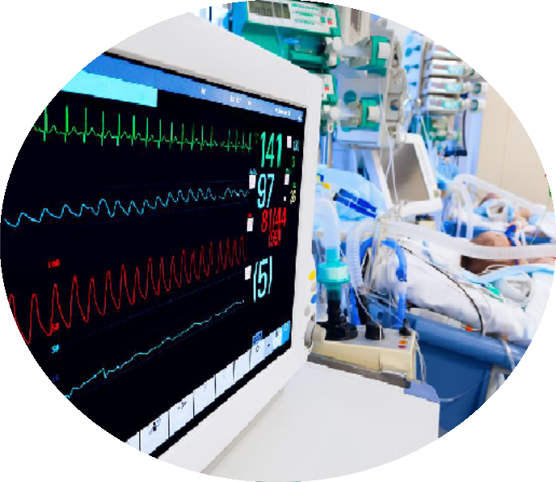

Hosted by: Ernest Mario School of Pharmacy, Rutgers, The State University of New Jersey

April 14th, 2023
8:00 am – 2:00 pm

A CME, CNE, and ACPE CE accredited activity provided by RBHS Rutgers Ernest Mario School of Pharmacy

Location: Virtual Platform (Zoom)
Rutgers, The State University of New Jersey 160 Frelinghuysen Road
Piscataway, NJ 08854

UAN# JA0000855-0000-23-002-L01-P (Knowledge-Based Activity)
5.0 Contact hours (0.50 CEUs)

ACCME, ANCC, and ACPE CE accredited activity provided by RBHS Rutgers Ernest Mario School of Pharmacy
Total: 5.00 Contact Hours (0.50 CEUs)
This knowledge-based activity UAN# JA0000855-0000-23-002-L01-P for a total of 5.00 contact hours (0.50 CEUs) of continuing education.

In support of improving patient care, Rutgers Biomedical and Health Sciences is jointly accredited by the Accreditation Council for Continuing Medical Education (ACCME), the Accreditation Council for Pharmacy Education (ACPE), and the American Nurses Credentialing Center (ANCC), to provide continuing education for the healthcare team.

This activity is designed for Pharmacists, Physicians, Nurses, and other Health Care Professionals. This program is organized by the Ernest Mario School of Pharmacy. All individuals who affect the content of continuing education activities are required to disclose to the audience any real or apparent conflict of interest related to the activity. The activity faculty are further required to disclose discussion of off-label/investigational uses in their presentations. These disclosures will be made to the audience at the time of the activity.
Requirements for completion – Participants must be in attendance for the entire program. All attendees MUST register online AND sign in and complete the online pre-test/post-test and program evaluation to receive program credit. This activity is awarded 5.00 Contact Hours. No partial credit will be awarded.
Pharmacists: CPE credit will be processed after the program evaluation has closed to participants, which will be three to four weeks following the activity date. Kindly view your credits at MyCPEmonitor.net.
Nurses: CNE credit certificates can be obtained immediately from your MyCe profile in Rutgers.Cloud- CME.com after completing the online evaluation.
Physicians: CME credit certificates can be obtained immediately from your MyCe profile in Rutgers.Cloud- CME.com after completing the online evaluation.
For additional program information, questions, or concerns, or if you require special arrangements to attend this activity, please contact RBHS Ernest Mario School of Pharmacy Office of Continuing Education, Debra Diller at 848-445-6823 or ce@pharmacy.rutgers.edu.

RBHS reserves the right to modify the activity content, faculty, and activities and reserves the right to cancel this activity if necessary.

Purpose:
Critical care professionals encounter a wide variety of disease states and related pharmacotherapies daily in their practice. New advances can be challenging for healthcare providers to stay abreast of new clinical research and evolving guidelines that impact medication use in the critically ill. Rutgers Critical Care Symposium is designed to provide an overview of a wide variety of pharmacotherapy controversies, an update on modern medical imaging, and new standards influencing the practice of critical care, including speaker insights on recent evidence-based recommendations. Symposium will include topics such as, but not limited to, beta-lactam antibiotics therapeutic drug monitoring (TDM), controversies surrounding the use of tenecteplase vs. tissue plasminogen activator for stroke thrombolysis, debate on best strategies for monitoring continuous paralysis, and applications of point of care ultrasonography (POCUS) in the intensive care unit (ICU).

Learning Objectives:
At the conclusion of this activity, the critical care professional participant should be able to:

- Review the evolving role of Thromboelastography and modern hemostatic resuscitation practices
- Discuss beta-lactam antibiotics TDM, review supporting evidence, and provide guidance for implementation in the critically ill
- Debate the risks and benefits of Tenecteplase vs. tissue plasminogen activator for stroke thrombolysis
- Evaluate best practices for selecting a paralytic agent, dosing, and monitoring in the ICU
- Integrate POCUS for hemodynamic monitoring in the ICU

Agenda:

8:00 - 8:10 | Welcome and Opening Remarks
8:10 - 9:10 | Evolving Role of Thromboelastography and modern hemostatic resuscitation practices  Bryan Cotton, MD  Professor Department of Surgery  The University of Texas Health Science Center at Houston
9:10 - 10:10 | Dosing Strategies of Paralytics for Acute Respiratory Distress Syndrome  Alex Flannery PharmD Assistant Professor  The University of Kentucky, College of Pharmacy  Best Practices in Monitoring Paralytics  Amita Avadhani, PhD, DNP Professor-Clinical Educator  Rutgers Biomedical & Health Sciences (RBHS) Rutgers, The State University of New Jersey  Depolarizing vs. Nondepolarizing Paralytics in Rapid Sequence Intubation  Megan Rech PharmD  Emergency Medicine Clinical Pharmacist and Research Director Loyola University Medical Center
10:10 - 10:20 | Speaker Panel 1: Q and A
10:20 - 10:40 | Break & Virtual Exhibit
10:40 - 11:40 | Controversies Surrounding TNK vs. TPA for Stroke Thrombolysis  Neha Dangayach MD  Associate Professor of Neurology and Neurosurgery Mount Sinai Hospital
11:40 - 12:40 | POCUS for Hemodynamic Monitoring in the ICU  Ibrahim El-Husseini MD Assistant Professor of Medicine  Robert Wood Johnson University Hospital
12:40 - 12:45 | Break & Virtual Exhibit

12:45 -1:45 | TDM of Beta-Lactam Antibiotics  Erin Barreto PharmD  Associate Professor of Pharmacy and Medicine Mayo Clinic
1:45 - 1:55 | Speaker Panel 2 Q and A
1:55 - 2:00 | Closing Remarks/Instruction
The following contributors have no relevant financial relationships with commercial interests to disclose:

Activity Directors
Maria Cardinale-King, PharmD, BCPS, BCCCP; Clinical Assistant Professor Ernest Mario School of Pharmacy, Rutgers, The State University of New Jersey

Activity Reviewer
Deepali Dixit, PharmD, BCPS, BCCCP, FCCM; Clinical Associate Professor Ernest Mario School of Pharmacy, Rutgers, The State University of New Jersey

Thalia Thomas, RN, MPA, MSN
Case Manager, RWJ Barnabas Health

Paul Weber, MD, RPh, MBA
Center for Continuing and Outreach Education Rutgers, The State University of New Jersey

